Statement Testing & Coverage

What is Statement Testing
# Source: AI Source: Provided by: [Data Path: Persons Table -> ID Column: 1, Name_En Column: Motasem Essam] -> From: [Chatgpt (GPT‑5 Mini)] on [8/24/2025]
Statement Testing is a white-box testing technique where the goal is to execute every possible statement (line of code) in the program at least once during testing.
Statement Coverage is the metric that measures the percentage of statements actually executed by the test cases.

✅ Why use it?
# Source: AI Source: Provided by: [Data Path: Persons Table -> ID Column: 1, Name_En Column: Motasem Essam] -> From: [Chatgpt (GPT‑5 Mini)] on [8/24/2025]
- To ensure no line of code is left untested.
- Helps detect unused, missing, or dead code.
- Ensures basic completeness of test execution.

📊 Formula for Statement Coverage:
# Source: AI Source: Provided by: [Data Path: Persons Table -> ID Column: 1, Name_En Column: Motasem Essam] -> From: [Chatgpt (GPT‑5 Mini)] on [8/24/2025]
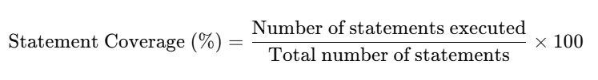
Statement Coverage (%)=Number of statements executedTotal number of statements×100\text{Statement Coverage (\%)} = \frac{\text{Number of statements executed}}{\text{Total number of statements}} \times 100

🔍 Example:
# Source: AI Source: Provided by: [Data Path: Persons Table -> ID Column: 1, Name_En Column: Motasem Essam] -> From: [Chatgpt (GPT‑5 Mini)] on [8/24/2025]
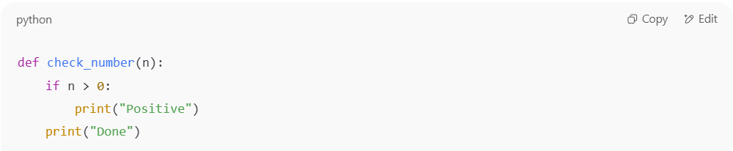
def check_number(n):
if n > 0:
print("Positive")
print("Done")

- Statements:
  - if n > 0:
  - print("Positive")
  - print("Done")
- Test Case 1: n = 5
  - Executes statements 1, 2, 3 → 100% coverage
- Test Case 2: n = -2
  - Executes statements 1, 3 → 2 out of 3 = 66% coverage
👉 To achieve 100% statement coverage, you must test with at least one positive number.

⚖️ Advantages:
# Source: AI Source: Provided by: [Data Path: Persons Table -> ID Column: 1, Name_En Column: Motasem Essam] -> From: [Chatgpt (GPT‑5 Mini)] on [8/24/2025]
- Simple and easy to apply.
- Ensures all lines of code run at least once.

⚠️ Limitations:
# Source: AI Source: Provided by: [Data Path: Persons Table -> ID Column: 1, Name_En Column: Motasem Essam] -> From: [Chatgpt (GPT‑5 Mini)] on [8/24/2025]
- Does not guarantee decision logic is fully tested (e.g., true/false conditions).
- May miss logical errors if only one branch of a condition is tested.

✅ In short:
Statement Testing checks whether every statement runs, and Statement Coverage measures how much of the code was actually executed during tests.

